**Brief T-sql From T-Sql Fundamental Book**

**Chapter 1:**

**T-SQL is both a subset and a superset of SQL**

**An RDBMS: is a database management system based on the relational model (a semantic model for representing data), which in turn is based on two mathematical branches: set theory and predicate logic**

**Important book:** SQL and Relational Theory: How to Write Accurate SQL Code, Third Edition by C. J. Date (O’Reilly Media, 2015).

**The SQL standard is made of multiple parts. Part 1 (Framework) and Part 2 (Foundation) pertain to the SQL language, whereas the other parts define standard extensions, such as SQL for XML and SQL-Java integration**

**That is, SQL requires you to specify what you want to get and not how to get it, letting the RDBMS figure out the physical mechanics required to process your request.**

**Set theory: no meaning for order set attribute {a,b,c} or {b,c,a also called Columns and set of tuble**

**Also called rows**

**Predicate: is expression hold true or false like that (salary >500) this expression either true or false**

**The first version of the relational model was proposed by Codd in 1969 in an IBM research report called “Derivability, Redundancy, and Consistency of Relations Stored in Large Data Banks.”**

**A proposition is an assertion or a statement that must be true or false. For example, the statement, “Employee Itzik Ben-Gan was born on February 12, 1971, and works in the IT department” is a proposition**

**Three-valued predicate logic refers to the three possible logical values that can result from a predicate—true, false, and unknown.**

**Attribute: any attributes or headers of table has name and type**

**ex:employeeId Integer**

**Normalization : is a formal mathematical process to guarantee that each entity will be represented by a single relation.**

**1NF**

**The first normal form says that the tuples (rows) in the relation (table) must be unique and attributes should be atomic. This is a redundant definition of a relation; in other words, if a table truly represents a relation, it is already in first normal form.**

**You achieve unique rows in SQL by defining a unique key for the table.**

**2NF**

**The second normal form involves two rules. One rule is that the data must meet the first normal form. The other rule addresses the relationship between nonkey and candidate-key attributes.**

**Fig 1 violate 2NF**

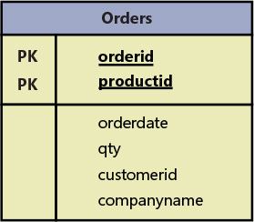

Figure

Solution Split this entity into two

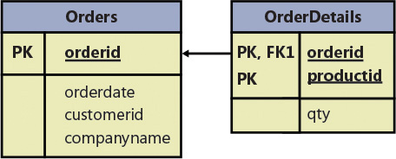

Figure

**3NF**

**The third normal form also has two rules. The data must meet the second normal form. Also, all nonkey attributes must be dependent on candidate keys nontransitively. Informally, this rule means that all nonkey attributes must be mutually independent. In other words, one nonkey attribute cannot be dependent on another nonkey attribute.**

**Fig3 solve problem**

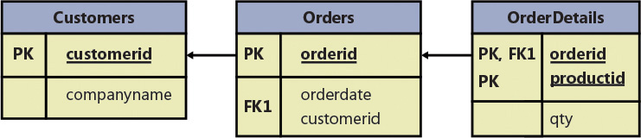

Figure

**Data lifecycle**

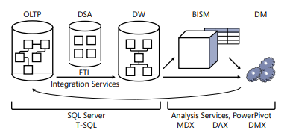

Figure

Here’s a quick description of what each acronym represents:

■ OLTP: online transactional processing

■ DSA: data staging area

■ DW: data warehouse

■ BISM: Business Intelligence Semantic Model

■ DM: data mining

■ ETL: extract, transform, and load

■ MDX: Multidimensional Expressions

■ DAX: Data Analysis Expressions

■ DMX: Data Mining Extensions

**OLTP**

The focus of an OLTP system is data entry and not reporting.

Entry : Insert , update , delete

Reporting required multiple join and that lead to degrading in query performance because **OLTP make table for each entity so** for generate reporting we require many join this resulting poor performing queries

**Data warehouse**

is an environment designed for data retrieval and reporting purposes ,

when it serves only part of the organization (such as a specific department) ,

fewer tables, and simpler relationships, ultimately resulting in simpler and more efficient queries as compared to an OLTP environment.

**Etl :transform data from OLTP To Data warehouse using Microsoft sql server integration service (ssis)**

**Etl stands for extract,transform,load**

**The Business Intelligence Semantic Model**

model for supporting the entire BI stack of applications. The idea is to provide rich, flexible, efficient, and scalable analytical and reporting capabilities. Its architecture includes three layers: the data model, business logic and queries, and data access.

**The business logic** and queries use two languages: Multidimensional Expressions (MDX), based on multidimensional concepts, and Data Analysis Expressions (DAX), based on tabular concepts.

**Data mining**

instead of letting the user look for useful information in the sea of data, data mining models can do this for the user. That is, data mining algorithms comb the data and sift the useful information from it. Data mining has enormous business value for organizations, helping to identify trends, figure out which products are purchased together, predict customer choices based on specific parameters, and more. Analysis Services supports data mining algorithms—including clustering, decision trees, and others— to address such needs. The language used to manage and query data mining models is Data Mining Extensions (DMX).

**SQL Server Architecture**

**The ABC Flavors of SQL Server**

internally referred to as the ABC flavors: A for Appliance, B for Box, and C for Cloud

**A**

provide a complete solution including hardware, software, and services. The appliance is hosted locally at the customer site. There are several appliances available today, one of which is Parallel Data Warehouse (PDW). Microsoft partners with hardware vendors such as Dell and HP to provide the appliance offering. Experts from Microsoft and the hardware vendor handle the performance, security, and availability aspects for the customer.

**B**

the traditional one, usually installed on the customer’s premises. The customer is responsible for everything—getting the hardware; installing the software; and handling updates, high availability and disaster recovery (HADR), security, and everything else. The customer can install multiple instances of the product in the same server (more on this in the next section) and can write queries that interact with multiple databases. It is also possible to switch the connection between databases, unless one of them is a contained database. The querying language used is T-SQL. You can run all of the code samples and exercises in this book on an on-premises SQL Server implementation, if you want. See the Appendix for details about obtaining and installing an evaluation edition of SQL Server, as well as creating the sample database

**C**

cloud and can be private or public

■ **master** The master database holds instance-wide metadata information, server configuration, information about all databases in the instance, and initialization information.

■ **Resource** The Resource database is a hidden, read-only database that holds the definitions of all system objects. When you query system objects in a database, they appear to reside in the sys schema of the local database, but in actuality their definitions reside in the Resource database.

■ **model** The model database is used as a template for new databases. Every new database that you create is initially created as a copy of model. So if you want certain objects (such as data types) to appear in all new databases that you create, or certain database properties to be configured in a certain way in all new databases, you need to create those objects and configure those properties in the model database. Note that changes you apply to the model database will not affect existing databases—only new databases that you create in the future.

■ **tempdb** The tempdb database is where SQL Server stores temporary data such as work tables, sort space, row versioning information, and so on. SQL Server allows you to create temporary tables for your own use, and the physical location of those temporary tables is tempdb. Note that this database is destroyed and recreated as a copy of the model database every time you restart the instance of SQL Server.

■ **msdb** The msdb database is where a service called SQL Server Agent stores its data. SQL Server Agent is in charge of automation, which includes entities such as jobs, schedules, and alerts. The SQL Server Agent is also the service in charge of replication. The msdb database also holds information related to other SQL Server features such as Database Mail, Service Broker, backups, and more